Case Study: GCC

Introduction

The correctness of compilers is critical to the health and reliability of other programming frameworks, because flaws in compilers might produce executables that do not reflect the intent of software engineers. Such errors are difficult to identify and analyse. Arbitrary test programme generators are frequently used in compiler testing, and they have proven to be effective in uncovering flaws. Nonetheless, the problem of guiding these test generators to produce test programmes that are sure to detect flaws persists.

Because of their size and complexity, testing compilers is exceptionally difficult. Testing such large, contemporary frameworks is a major task; nonetheless, experts designers can uncover problems in them. Arbitrary testing, often known as fluffing, is a common, lightweight way for developing test programmes for compilers. Many programming languages have specific arbitrary test generators that use the language syntax and language-explicit heuristics to deliver test programmes in those languages. For C, are genuine examples of such test generators that have been effective in assisting designers in tracking down many bugs in various compilers and mediators.

Testing Strategy

We accept problem reports that provide experiences that may be extracted to further enhance the compiler test age. The intuition behind our process is that the language includes who have participated in previous issues would most likely participate in future problems as well. We devise various experiments and then examine them by comparing a few different approaches.

Following is the workflow of the testing

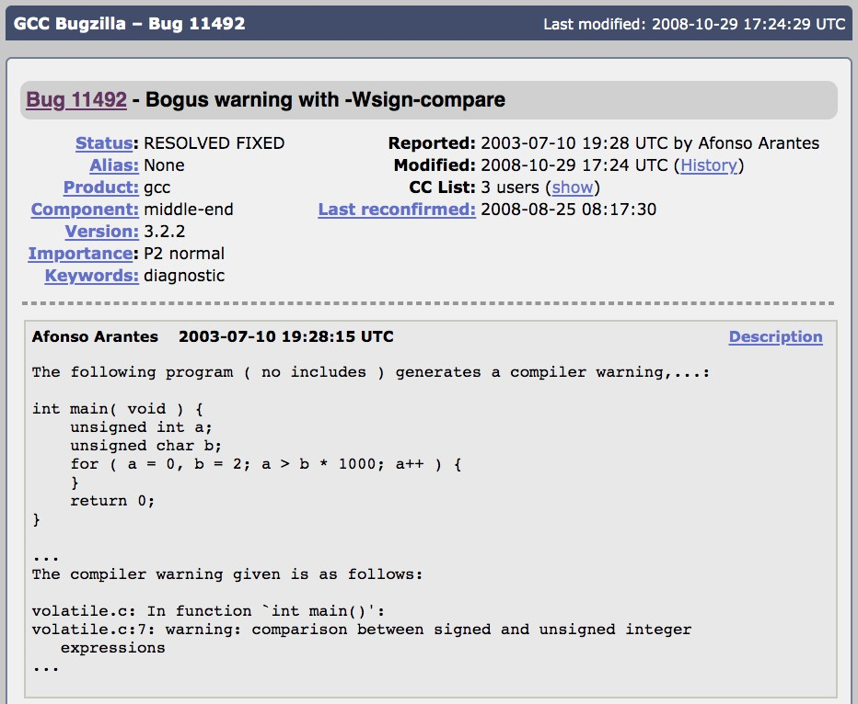

So the above may be one test case we can write in this case.

Albeit comparable in the instinct, rather than controlling existing test programs, this method utilizes designs to direct the test generator to create new test programs.

The following figure depicts the overall workflow of our testing process.

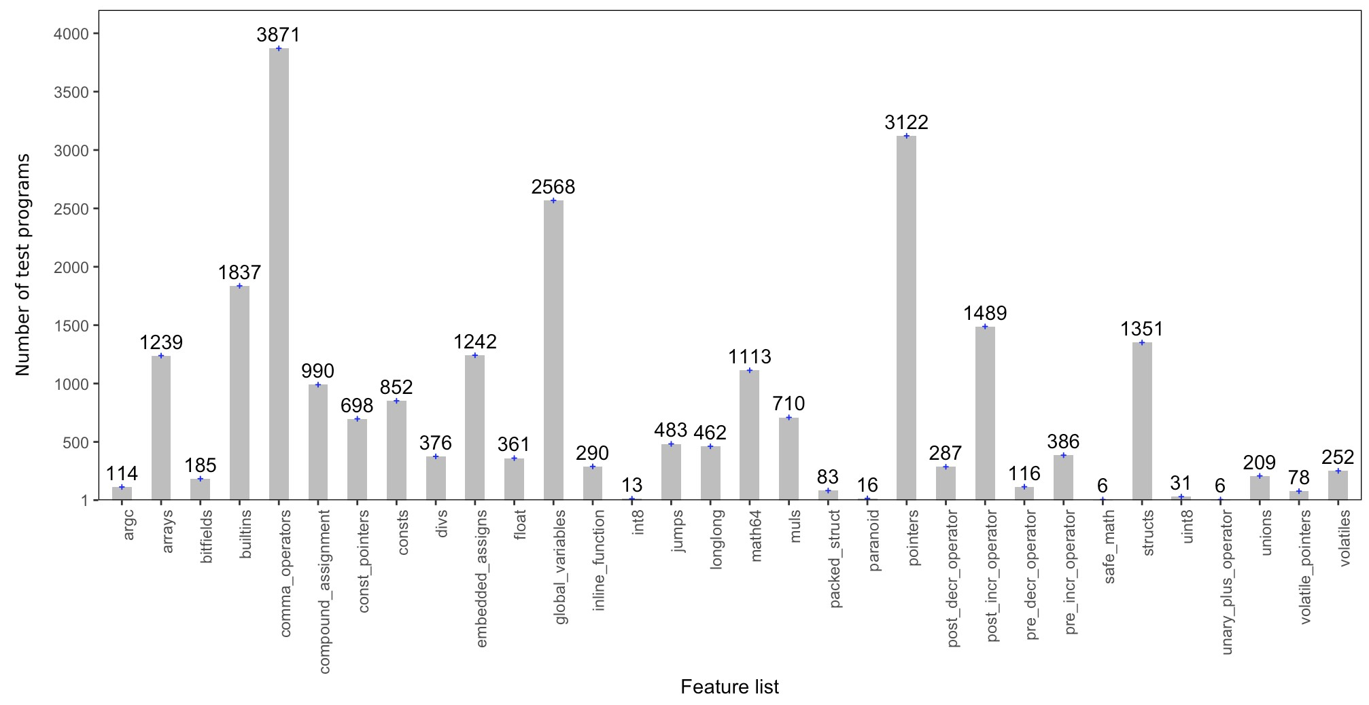

main steps:

(1) removing configurable test highlights from the underlying test suite,

(2) utilizing the test elements to bunch test programs into comparable gatherings, and

(3) creating arrangements in light of the centroid of groups. We portray each progression in the remainder of this part.

Following are the test results I get from the coverage of the tests I written.

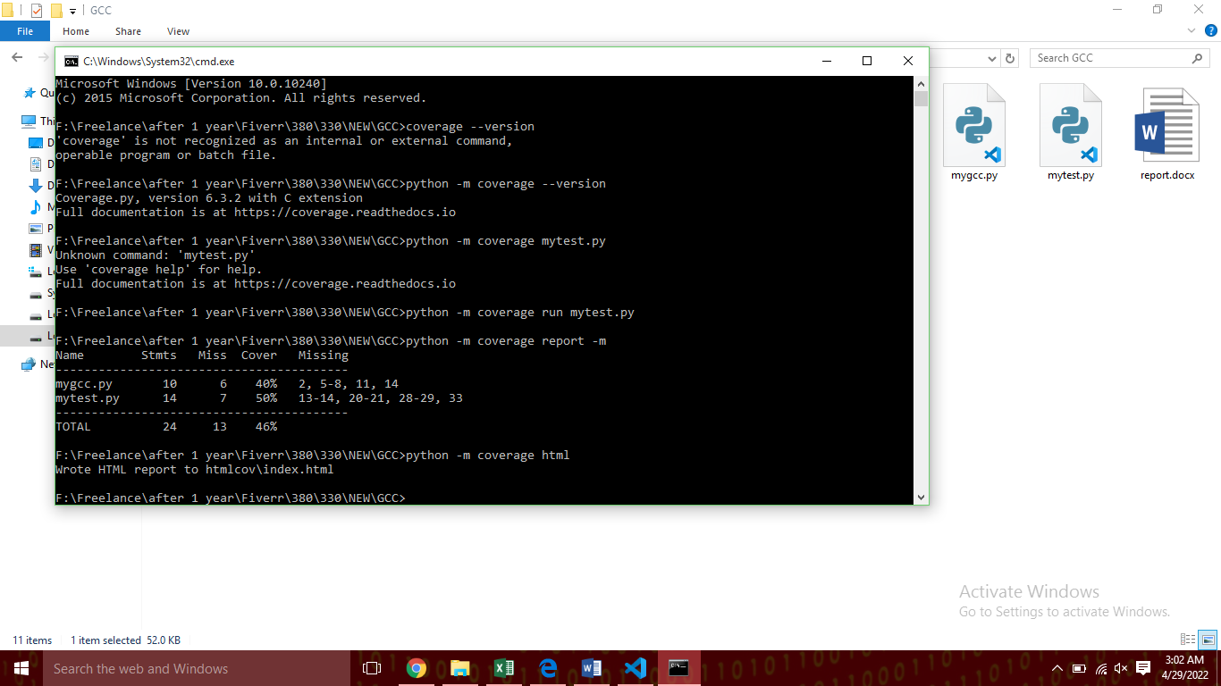

Above are the function coverage report of the files.

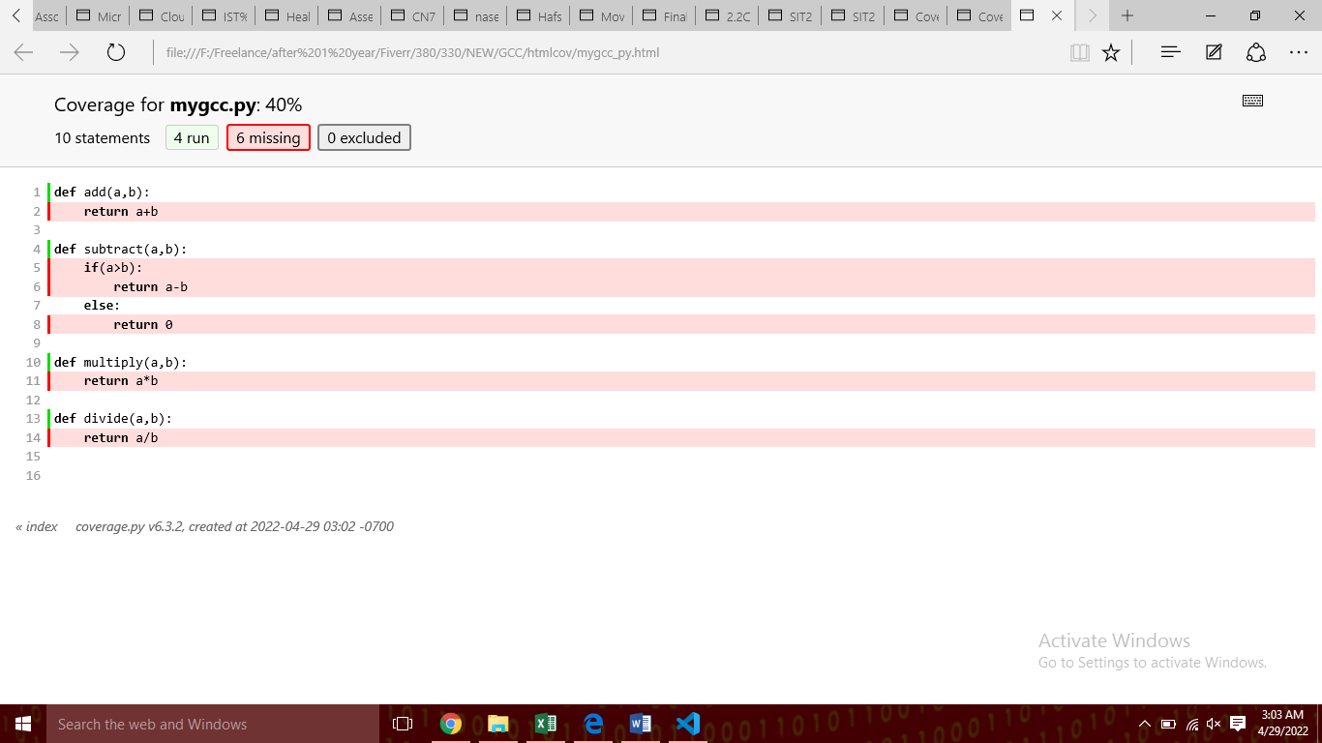

This figures show the test cases written and checked the code coverage I execute.

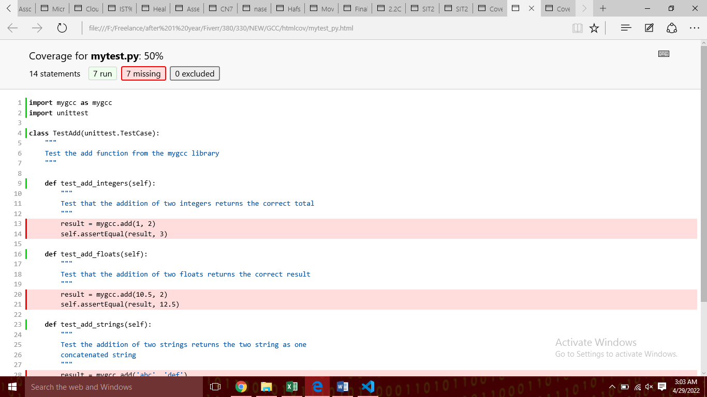

The figures shows the asserts statements at my test cases.

The above figures shows the asserts statements in the debug production files.

The code bits in the problem reports are used to control the test age. The main idea behind this effort is to take bits of knowledge from issue reports about language features that are more prone to poor execution and use the experiences to steer the test generators.

To evaluate the feasibility of this concept, we use the GCC C compiler. In particular, we initially group the test programmes in the GCC bug reports based on their highlights.

These experiments were taken from GCC test setups. In addition to the remedy, the designer typically does a relapse experiment by deleting the related problem setting off code from the defect report. In the meanwhile, a bug mark is created by linking a prefix pr and an infix bug-id, which is then used as the experiment's file name or inserted inside the experiment as a remark.

For example, the test case is written in experiment 00001.c. As a result, its narrative isn't as seamless as GCC's. In any event, the overall pattern in the two plots is comparable, which supports the end mentioned near the beginning of this section. This impression can be used to improve the efficacy of arbitrary testing for compiler approval.

Test I written:

Mygcc.py

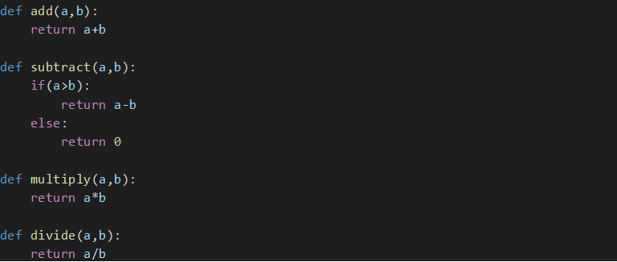

Now for testing these I make another class as following:

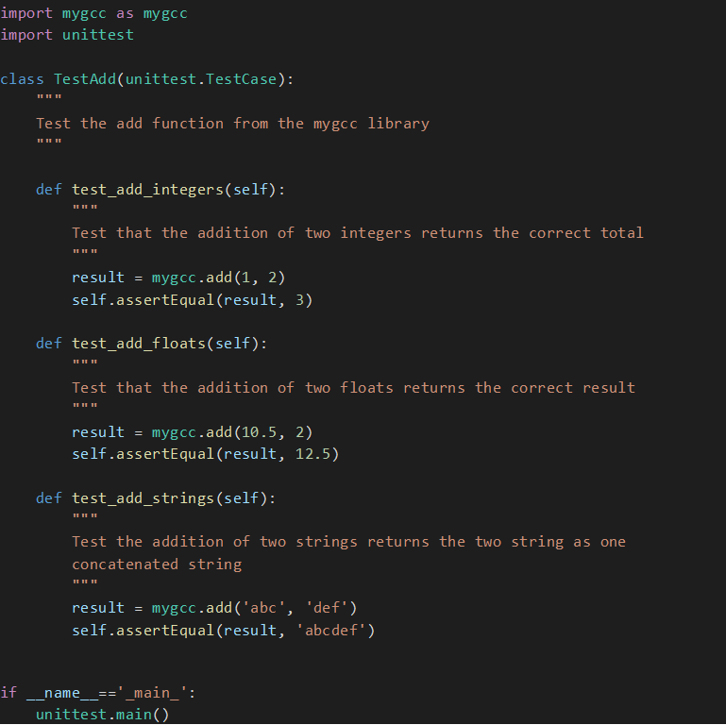

This class test the add function one by one using unit tests.

Steps:

1. First it tests the add function using integers.
2. Then using floats
3. Then using strings

Buggy GCC Components:

It's hardly surprising that the C++ components of the two compilers are the most unstable, given that C++ is the most sophisticated programming language. Nonetheless, it is astonishing that so little research has been conducted to evaluate C++. Despite the fact that it is more difficult than evaluating C compilers, it is extremely respectable because C++ is used as widely as C. Furthermore, given the most problematic files of the two compilers, we may go on to evaluating C++ by starting with the most buggy parts, such as formats and over-burden tactics.

Little Regression Tests displays the size of relapse trials, which are isolated from the test programmes attached to muck up results. 95 percent of them have fewer than 100 lines of code, and more than half have fewer than 25 lines of code.